## 2.1: Single Row Functions:

**1.** Display name and date of birth of students where date of birth must be displayed in the format similar to “January, 12 1981” for those who were born on Saturday or Sunday.



**2.** Display each staff name and number of months they worked for the organization. Label the column as ‘Months Worked’. Order your result by number of months employed. Round the number of months to closest whole number.

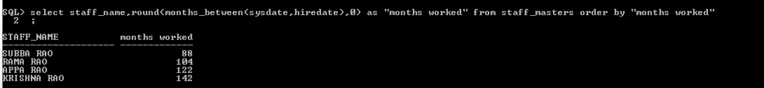

**3.** List the details of the employees, whose names start with ‘A’ and end with ‘S’.

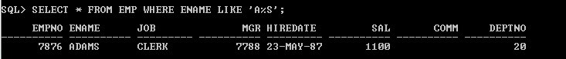

**4.** List the name and job of the employees whose names should contain N as the second or third character, and ending with either ‘N’ or ‘S’.



**5.** Create a query which will display Staff Name, Salary of each staff. Format the salary to be 15 character long and left padded with ‘$’.



**6.** List the names of the Employees having ‘_’ character in their name.

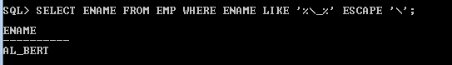

**7.** List the details of the employees who have joined in December (irrespective of the year).

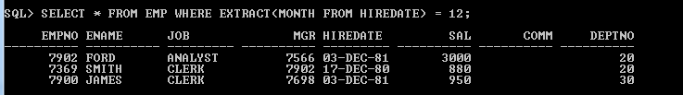

**8.** Write a query that displays Staff Name, Salary, and Grade of all staff. Grade depends on the following table.

|  |  |
| --- | --- |
| Salary | Grade |
| Salary >=50000 | A |
| Salary >= 25000 < 50000 | B |
| Salary>=10000 < 25000 | C |
| OTHERS | D |

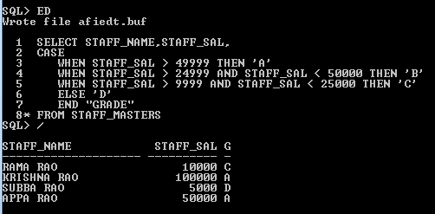

**9.** Display the Staff Name, Hire date and day of the week on which staff was hired. Label the column as DAY. Order the result by the day of the week starting with Monday.

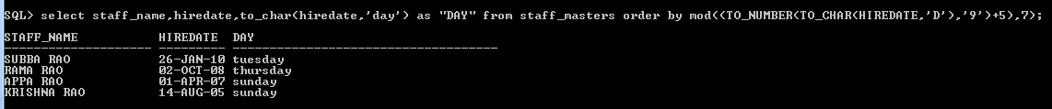

**10.** Show staff names with the respective numbers of asterisk from Staff table.

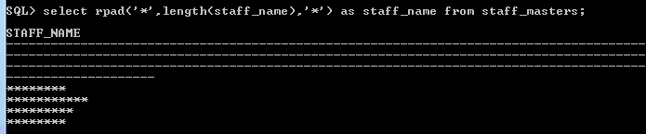

**11.** Show staff names with the respective numbers of asterisk from Staff table except first and last characters. For example: KING will be replaced with K**G.   
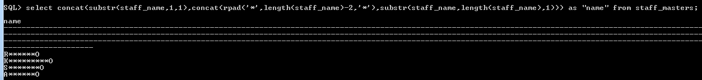

**12.** Show all staffs who were hired in the first half of the month.

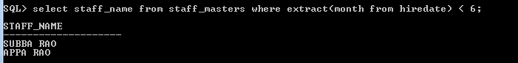

**13.** Display the staff name, hire date and day of the week on which the staff joined. Order the results by the day of the week starting with Monday.



**14.** Write a query to find the position of third occurrence of ‘i’ in the given word ‘Mississippi’.

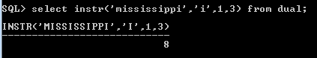

**15.** Write a query to find the pay date for the month. Pay date is the last Friday of the month. Display the date in the format “Twenty Eighth of January, 2002”. Label the heading as PAY DATE.

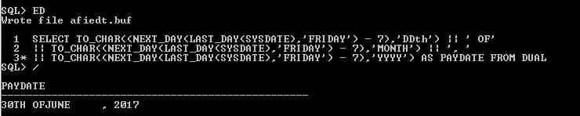

## 2.2: Group Functions:

**16.** Display the Highest, Lowest, Total & Average salary of all staff. Label the columns Maximum, Minimum, Total and Average respectively. Round the result to nearest whole number.



**17.** Edit the above query and display the same for each Department Name.

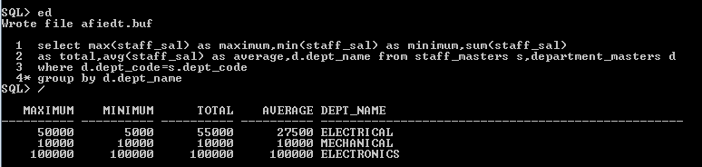

**18.** Write a query to display number of people in each Department. Output should display Department Code, Department Name and Number of People.

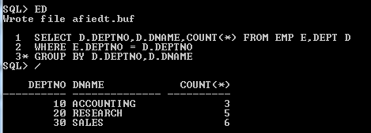

**19.** Determine the number of managers without listing them. Label the column as ‘Total Number of Managers’.

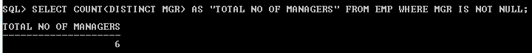

**20.** Display Manager Code, Manager Name and salary of lowest paid staff in that manager’s team. Exclude any group where minimum salary is less than 10000. Order the result on descending order of salary.

